Title or Task: |   

Description:

Files Required
Suitable for Classes: | AIT • Multimedia • Cert II IT • Cert II Bus
Area: | Technology & Enterprise
Teacher: | Mr Peter Faulks

Timeline

Date Due:
Task Brief: | In class lesson

Outcomes:

Items highlighted in yellow are tasks for you to complete
Items in Blue italics are help tips

These pages are designed to show you how to use software packages; various software updates may have taken place so some pages will not apply to versions other than those listed here. In some cases data files may be required.

SOLUTIONS
Office Quiz

GENERAL KNOWLEDGE

- Name Arial 16

(1 mark)

Ivan Interestingnayme

- List three ways you can demonstrate good ergonomic practices in a classroom? (3 marks)

- Chairs up to computer desk

- Monitor at eye level

- Good posture

- Name three software applications you have used this year.
Describe at least one situation for each of the applications.

(6 marks)

- Word – making letterheads

- Excel – Creating a budget

- Power Point making a presentation

- Explain the technology process in your own words.

(4 marks)
Investigate Devise Produce Evaluating

WORD PROCESSING

- Explain the steps involved in changing the page margins?

(2 marks)
File, Page Set Up , Margins

- Write your name in the space below and format it as follows:
Arial 16, bold, underline (1 mark)

- When typing a letter how many returns are left between the date and inside address? (1 mark)

Three returns

- Where would I go to change the line spacing of a paragraph?

(1 mark)

Format Paragraphs

- What does it mean if a letter is fully blocked
(2 marks)

Full page

- A letter has open punctuation when…? (2 marks)

When using open punctuation exclude all unnecessary punctuation marks such as full stops in abbreviations, for example, Mr D R Bright, eg, etc. Leave one space after an initial of a name, for example, D Watson. Open punctuation is the most widely used punctuation style.

- Why is it important to print preview your work before printing.
(1 mark

Layout and format

- Using the table below do the following: (6 marks)

- split row 4 into 8 columns (Insert cell to right)

- shade rows 1 and row 4 grey (Toolbar tables fill)

- put a double line border between rows 1 and 2

- head each column with the name of a month eg January, March

- increase the size of each column heading to 16

- add a colour to the top row

January |  | Feb |  | March |  | April

- What is the quickest way of moving between the cells of a
table? (1 mark)

Tab

- What tab alignment usually used for numbers?

(1 mark)

Left tab

- What is the default setting for tabs? (1 mark)

1.27 cm

POWERPOINT

- When choosing a slide layout how many choices do you
have? (1 mark)

- 8

- 10

- 12

- Write the names of three slide layout choices that you used
in your presentation? (3 marks)

Answers will vary

- Under which menu do you change the slide background?
(1 mark)
Format Slide layout

- How many different ways can you view your presentation?
(1 mark)

- 2

- 4


- 5

POWERPOINT

- What is the name of the following slide view? (1 mark)

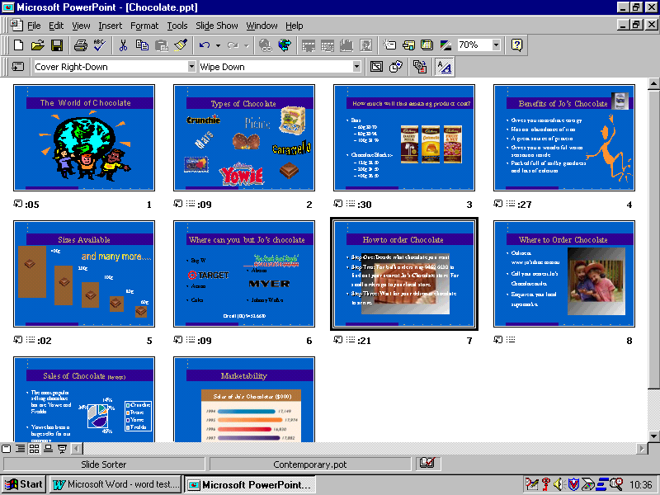Slide Layout View

- Follow the arrow. What do these three symbols stand for?

(3 marks)
- Transition
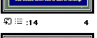
- Auto Time

- Time Duration

- Why would you include timings in your PowerPoint
presentation? (1 mark)

More professional

Desktop Publishing

- On the three-fold brochure design, specify where you would
type the following: (6 marks)

- Front cover
- Back cover
- Inside flap
- Inside information 1
- Inside information 2
- Inside information 3

Page 1

- Back cover | - Inside flap | - Front cover

Page 2

- Inside information 1 | - Inside information 2 | - Inside information 3



